TEST TABLE FOR DSA PROJECT.

SHAHEER DASTGIR.

DSA SEMESTER PROJECT.

**1. Test Login Functionality:**

- Test logging in as a library staff member with valid credentials.

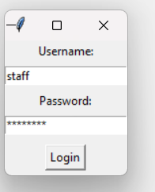

- Test logging in with invalid credentials (wrong username or password).

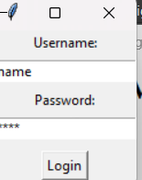

**2. Test Add Book Functionality:**

- Test adding a new book to the library catalog.

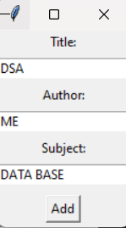

- Verify that the book is correctly added to the catalog and saved to the file.

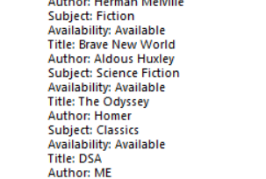

**3. Test Remove Book Functionality:**

- Verify that the book is correctly removed from the catalog and saved to the file.

- Test removing a book that does not exist in the catalog.

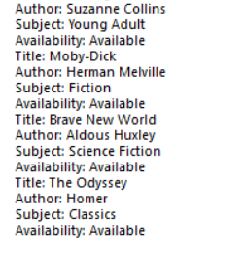

**4. Test Modify Book Functionality:**

- Test modifying the details of a book in the library catalog.

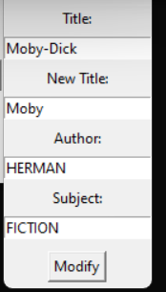

- Verify that the book details are correctly updated and saved to the file.

**5. Test Sort Books Functionality:**

- Test sorting books by title and verify that the books are displayed in alphabetical order.

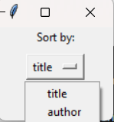

6. Test register user functionality:



